**Augment Reality Objects Prototype**

The aim of this prototype is to answer the technical question of is “marked tracking” a viable method of displaying and moving objects in our augmented reality 3d space with particular emphasis on range and accuracy.

**Initial prototype**

The first attempt at displaying and moving augmented reality objects was created on Unity using the Vuforia [reference] augmented reality library. It works by setting up a database of markers/trackers which are objects with enough unique elements to be picked up by a camera and be distinguishable from their surroundings. We then attach computer generated 3d objects to these “targets”, and when the software is ran the user can visualise these augmented reality objects superimposed on top of their real tracker cards.

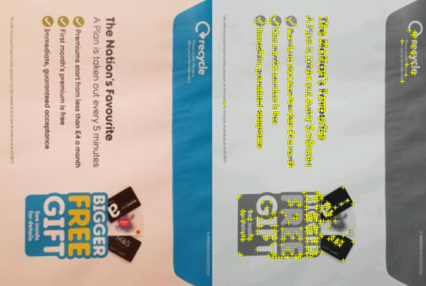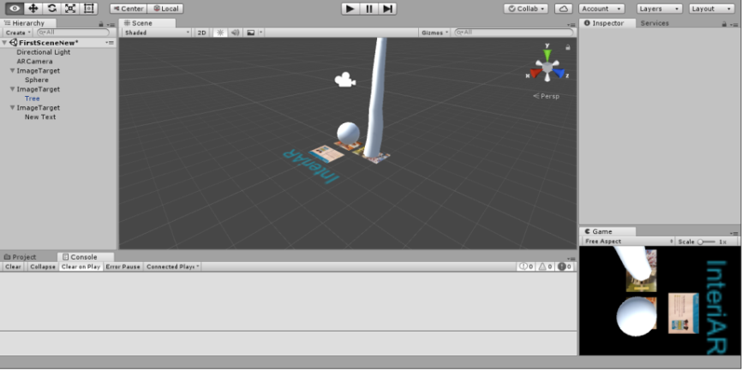

Vuforia AR objects prototype v1 in Unity Marker/tracker displayed with “features”

As displayed in the images below, the close up functionality is great, even when dealing with inconsistent lighting. However as soon as the range is increased and natural angle altered, it quickly becomes incapable of consistently tracking the markers.

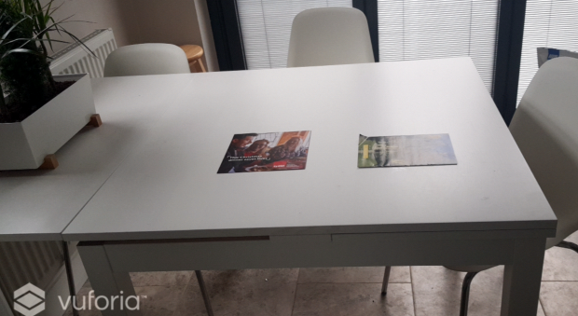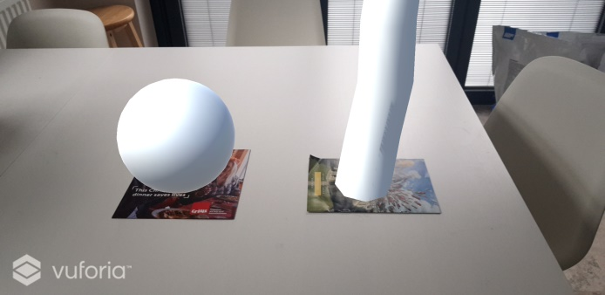

Vuforia AR objects prototype v1 deployed to android Vuforia AR objects prototype v1 at range

**Thoughts going forwards**

It seems due to the issues stated above, we should look more into marker-less tracking as opposed to, or in conjunction with this implementation for our project. Markers are great for close up accuracy and moving small objects around, but fall back when trying to get a wide angled shot.

One possible avenue to research is having markers to initially place the object in the 3d space and then keeping the object anchored there rather than relying on always being able to see the marker.